Insert Header
  - Sub header
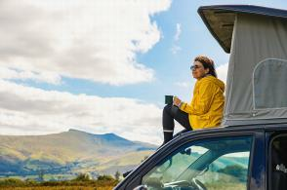

Personal Information
Full name | Person 1 | Person 2
Home address
Mobile phone
Birthday (MM/DD/YYYY)
Driver’s license number

Vehicle Information
Vehicle make/model/color
License plate #
Vehicle insurance & policy #

Emergency and Medical Information (copy and paste for additional individuals)
In case of emergency, contact
Emergency contact’s phone
Known allergies

Camping/Hotel Itinerary
Date | Campground/Hotel | City, Country | Reservation confirmation number | Phone number
(Right click > Insert > Add more rows above or below)

Hiking Options/Itinerary
Date | Location | Trail | Trail Length | Trail Rating

